**Installation**

This project is intended to create the basic structure and connection between modules in onion architecture.

You must first download the file and install it on the system.

After installation, you can see the project creation template by searching for keywords such as onion architecture.

Something like

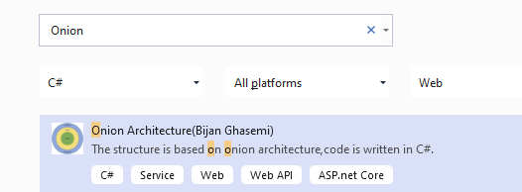

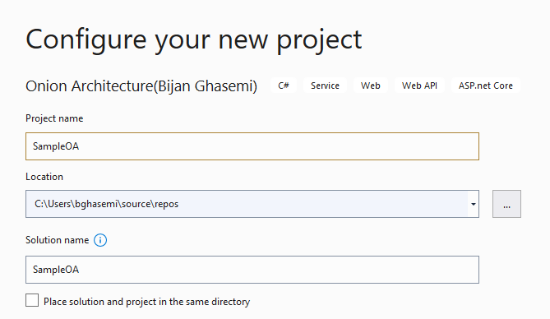

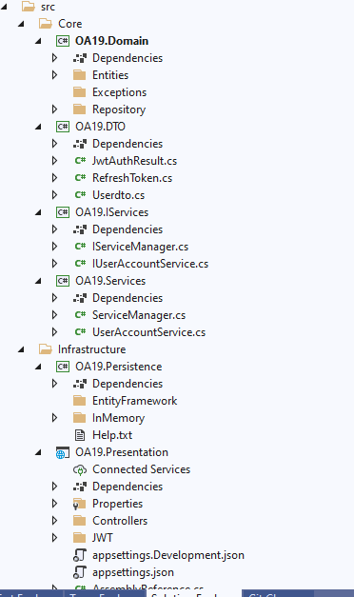

**Support Me.**

Buy Me A Coffee!(With digital currency)

Wallet address:

Tron(trx)

TRwMczeB2NiQv2ymJh5pA7butgmiRPQGbA

Dogecoin

DPE2L9BGkJ3gyzmiNoqUiEk6X2epmipjSE